

**ST.PAUL’S UNIVERSITY**

**SCHOOL OF BUSINESS AND COMMUNICATION**

**DEPARTMENT OF BUSINESS AND INFORMATION TECHNOLOGY**

**SOFTWARE AS A SERVICE ENTERPRISE RESOURCE PLANNING SYSTEM**

**MARTIN MBITHI NZILANI**

**BSC MKS 275517**

**SUPERVISOR: MR.WILSON MUSYOKA**

**THIS PROPOSAL RESEARCH IS SUBMITTED IN PARTIAL FULFILMENT OF REQUIREMENT FOR THE AWARD OF**

**BACHELOR OF SCIENCE IN COMPUTER SCIENCE**

**IN ST. PAUL’S UNIVERSITY**

# **DECLARATION**

I hereby declare that this project report submitted by me to St. Paul’s University in partial fulfillment of the requirement for the award of Degree in Computer Science is a record of bona fide project work carried out by me under the guidance of Mr. Wilson Musyoka. I further declare that the work reported in this project has not been submitted by any other person in this institution or any other.

**NAME: MARTIN MBITHI NZILANI**

**SIGNATURE: …………………........**

**ADM NO: BSCMKS275517**

**DATE: 23/02/2021**

**SUPERVISOR**

This project proposal has been submitted for examination with my approval as the university supervisor.

Signature............................................................. Date..........................................

**DEDICATION**

I dedicate this proposal work to my beloved parents for their financial support, and to the rest of my family for having guided and encouraged me to this point of achievement in my life and to my friends who also guided and made this possible to me.

# **ACKNOWLEDGMENT**

My outmost gratitude goes out to the Lord Almighty for protection and provision He gave me during the whole period of this research.

Secondly, to my beloved parents for their encouragement, guidance, support and having faith in me, May the lord bless you.

Thirdly, I acknowledge my university supervisor Mr. Wilson Musyoka for his guidance and academic support which has results to the completion of this research proposal.

Lastly, I want to acknowledge my colleagues especially my classmates for participation and team work they showed up during this journey.

**TABLE OF CONTENTS**

**DECLARATION** ii

**ACKNOWLEDGMENT** iv

**ABBREVIATIONS AND ACRONYMS** vii

**DEFINITION OF TERMS** viii

**ABSTRACT** ix

**CHAPTER ONE** 1

**1.0 Introduction** 1

**1.1 Background Information** 2

**1.2 Challenges of Current Systems** 3

**1.3 Statement of the Problem** 4

**1.4 Objectives of the System** 5

**1.4.1 General Objectives** 5

**1.4.2 Specific Objectives** 5

**1.5 Justification** 6

**1.6 Scope and Limitation of the Study** 6

**CHAPTER TWO** 8

**LITERATURE REVIEW** 8

**2.0 Introduction** 8

**2.1 Related Literature** 8

**2.1.0 Microsoft Dynamics** 8

**2.1.1 SAP Business ByDesign** 9

**2.1.2 Odoo** 9

**2.1.3 ERPNext** 9

**2.1.4 Dolibarr** 9

**2.1.5 Microsoft Dynamics NAV** 10

**2.2 Conclusion** 10

**CHAPTER THREE** 12

**METHODOLOGY** 12

**3.0 Introduction** 12

**3.1 Data Collection / Sampling Methods** 12

**3.1.1 Interviews** 12

**3.1.2 Questionnaires** 13

**3.1.1 Observations** 13

**3.2 Proposes System Requirements** 14

**3.2.1 Functional Requirements** 14

**3.3.2 Non Functional Requirements** 16

**3.3 Design Methods** 16

**3.3.1 Flowchart Diagrams** 16

**3.3.2 Data Flow Diagram** 26

**3.4 Method for Developing** 28

**3.4.1 Gathering the requirements** 28

**3.4.2 Design** 28

**3.4.4 Implementation** 28

**3.4.5 Verifying and Testing** 28

**3.4.6 Maintenance** 29

**3.5 Method of Transition** 29

**3.6 Screenshots of the Proposed System** 29

**3.6.1 Subscription Management Ecosystem Screenshots** 29

**3.6.2 ERP Modules Screenshots** 31

**3.7 Conclusion** 34

**References** 35

# **ABBREVIATIONS AND ACRONYMS**

**SaaS -** Software as a Service

**ERP-** Enterprise Resource Planning

**SaaS ERP-** Software as a Service Enterprise Resource Planning System

**API-** Application Programming Interface

# **DEFINITION OF TERMS**

**Software As A Service -** Software as a service (SAAS) is a software licensing and delivery model in which software is licensed on a subscription basis and is centrally hosted by the vendor.

**Enterprise Resource Planning System -** Enterprise resource planning (ERP) refers to a type of software that organizations use to manage day-to-day business activities such as accounting, procurement, project management, risk management and compliance, and supply chain operations.

**Third-party Plugins –** Third party programs are small programs that are added to a software suite to provide additional functionalities.

**Application Programming Interfaces –** An application programming interface, is a computing interface that defines interactions between multiple software intermediaries. It defines the kinds of calls or requests that can be made, how to make them, the data formats that should be used and the conventions to follow.

**Payment Gateway -** A payment gateway is a merchant service provided by an e-commerce application service provider that authorizes credit card or direct payments processing for e-businesses.

# **ABSTRACT**

The aim of this research proposal is to establish and design a SaaS ERP Suite which will be delivered using subscription packages. Enterprise resource planning (ERP) systems have been one of the most popular business information management systems, with features like providing benefits of real-time capabilities and seamless communication for business departments in large organizations. However, ERP systems are majorly impacted by technological advancement and thus many organizations are shifting to Software as a Service ERPs which are delivered using a model in which the ERP software is licensed on a subscription basis and is centrally hosted by the vendor.

# **CHAPTER ONE**

## **1.0 Introduction**

Software as a service (SAAS) is a software licensing and delivery model in which software is licensed on a subscription basis and is centrally hosted by the vendor. It is sometimes referred to as "on-demand software", and was formerly referred to as "software plus services" by Microsoft. SaaS applications are also known as Web-based software, on-demand software and hosted software. SaaS apps are typically accessed by users using a thin client that is a web browser. (Jamsa, 2012)

SaaS has become a common delivery model for many business applications, including office software, messaging software, payroll processing software, DBMS software, management software, CAD software, development software, gamification, virtualization,accounting, collaboration, customer relationship management (CRM), management information systems (MIS), enterprise resource planning (ERP), invoicing, human resource management (HRM), talent acquisition, learning management systems, content management (CM), geographic information systems (GIS), and service desk management.

Enterprise resource planning (ERP) refers to a type of software that organizations use to manage day-to-day business activities such as accounting, procurement, project management, risk management and compliance, and supply chain operations. A complete ERP suite also includes enterprise performance management, software that helps plan, budget, predict, and report on an organization’s financial results. ERP systems tie together a multitude of business processes and enable the flow of data between them. By collecting an organization’s shared transactional data from multiple sources, ERP systems eliminate data duplication and provide data integrity with a single source of truth. (Arik Ragowsky, 2002)

ERPs also provides an integrated and continuously updated view of core business processes using common databases which are maintained by a database management system. ERP systems track business resources—cash, raw materials, production capacity—and the status of business commitments such as orders, purchase orders, and payroll. The applications that make up the system share data across various departments (manufacturing, purchasing, sales, accounting, etc.) that provide the data.ERP facilitates information flow between all business functions and manages connections to outside stakeholders.

SaaS ERP is a type of cloud-based enterprise resource planning (ERP) software that runs on the vendor or cloud provider's servers, is sold through subscription and delivered as a service over the internet. It usually employs a multi-tenant Software as a Service architecture, in which multiple purchasers share the same instance, or copy, of the software, underlying infrastructure and database, but with each tenant's data securely separated. The vendor controls when the software is updated, usually quarterly, and all users get updates at the same time. Features of the software are standardized for everyone and cannot typically be customized easily. (Johansson & Ruivo, 2013)

SaaS ERP may also be offered in single-tenant mode where each customer gets its own instance of the software and database and typically has some control over updates and customization. Companies often choose single-tenant SaaS ERP to suit their privacy policy or to meet government regulations on data privacy and security.

## **1.1 Background Information**

The evolution of data management has led to challenges and opportunities for top managerial individuals of many organizations. Managerial decisions historically required that managers make sense of data from a variety of fragmented sources especially in multinational companies. Access to accurate and meaningful data are critical components of an organization’s operations and converging data from multiple sources to a single application facilitates an improvement in organization’s business processes and competencies.

Advancements in computing technology has enabled organizations to develop managing and processing data more efficiently. Infusing an ERP system with the proper managerial execution provides an organization the opportunity to make strides toward implementing strategic goals. However, a significant number of ERP system implementations did not meet the goals of the Organization. Approximately 90% of ERP system implementation projects exceed budget or delivery date and only about 30% of ERP system implementations are successful. Although the success rate is low, there are still benefits to implementing an ERP system. (Alhaisoni, 2008)

The amount of information in these organizations is heavily increasing and it has become vitally

important to efficiently manage and share information inside the organization. Companies

have to be swift in adopting new technology in order to remain competitive in a continuously developing business environment. This is where integration of Information Management systems come into play. Companies and other organizations are investing great sums in introducing information systems in the organization hoping to be able to make business more efficient and information sharing smooth.

An example of such an information system investigated in this proposal is an Enterprise Resource Planning (ERP) system. The quest for improving business processes and decision-making, integrating business units and their information flows has a long history. Computing and information technology advancements have enabled recent development in these spheres. This progress has led to emergence of Enterprise resource planning (ERP) systems which are at the forefront in company-wide IT solutions. (Alhaisoni, 2008)

## **1.2 Challenges of Current Systems**

An effective business strategy centers on an aggressive, efficient use of information technology; for this reason the ERP systems have emerged as the core of successful information management, and the enterprise backbone of the organization. A successful ERP system will streamline processes within a company and improve its overall effectiveness, while providing a means to externally enhance competitive performance, increase responsiveness to customers, and support strategic initiatives. Despite such advantages, there are some of the challenges that are evident in the current Enterprise Resource Planning Systems.

* Flexibility challenges. Many ERPs in the market today have flexibility issues and if this kind of an ERP is implemented in a certain organization, the organization has to adapt its processes to suit the ERP for it to work successful, This process is time and resource consuming for it would force the organization to re arrange all business activities, retrain their staff in order to make use of the implemented ERP.
* Maintenance costs. ERPs in the market today require regular checks and maintenances, and this price is paid by the target organization that has purchased a certain copy of an ERP. Many ERP systems might seem cheap to start with, but if the target organization does not factor in the maintenance costs attached to it before implementation, they can end up with overwhelmingly large sums to pay.
* Hardware investments. Computational hardware devices are required especially when a certain organization decides to implement an ERP, whether its cloud based or in house hosted. They will be required to purchase high end workstations which will be acting as servers for the ERP, personal computers, printers, scanners and all other equipment required in implementations of the ERP. The cost of purchasing and maintaining the above equipment is high. Also ERP applications require sufficient storage and high work performance and low investment in hardware may result in various software issues.
* Multi-currency support. Many ERPs in the market today lack this feature of handling more than one currency and converting it to local organization currency. Lack of this feature has led to implementation of other third party systems to act as currency converters.

## **1.3 Statement of the Problem**

The current style of enterprise resources planning and management is basically performed manually or on some of organizations simple Information Management systems are implemented to aid which they are not effective. Also it is evident that the cloud-based ERP has become popular.

This is because of its integrated nature in harmonizing all the departments and units of an organization all on one system as opposed to the past where different units used different systems which were all stand-alone, but this is not enough, because many cloud-based ERPs are hosted on the organizations Intranet and accessed over the network only in the organizations premises. Any employee cannot have access to the system if he or she is not connected to the organizations’ intranet.

This proposed system aims to implement a software as a service ERP which will be accessible by the subscribed organizations’ staff and employees everywhere anywhere. This proposed system also will not have any limitations like the ones evident in cloud-ERPs such as on premise access.

It will offer free subscriptions to middle level organizations which do not require complex features and functionalities thus reducing the complexity of the system. On high level corporations and also any other organization which will have to utilize all the complex modules of the Enterprise Resource Planning System, they will have to subscribe to non-free packages.

## **1.4 Objectives of the System**

### **1.4.1 General Objectives**

The general objective of this study is to evaluate the implementation of a Software as a Service Enterprise Resource Planning System.

### **1.4.2 Specific Objectives**

The specifics objectives of this study are:

* First the study will conduct data collection which will help in the analysis and design of the system during the system development.
* Secondly the study will create a system that will fulfill the user requirements and be able to perform various functions such as having an ecosystem that will manage clients` subscriptions to the ERP.
* The study will also perform system testing to ensure that the system performs all the functions effectively and in an efficient manner.
* Finally the study will implement the system and perform all the post implementation activities and maintenance of the system.

## **1.5 Justification**

* This study will contribute to the adoption of Software as Service ERPs systems in the assistance facilities through gathering information on the important factors which drives the adoption of information systems in organizations.
* This study will provide information to the top managerial personnel’s of many institutions and organizations which may help them to avoid problems that would arise if they fail to adopt Software as Service ERP Systems.
* The information gathered and generated in this study will enable stakeholders to come up with good plans and formulate policies that will favor adoption of Software as Service ERPs in their organizations.
* Also it is expected that the vendors will use the information from this study to develop ERP systems with desirable characteristics that will increase their adoption in the industry.
* Also, the findings of this study will be used to improve the management process and that the study findings can be applied in areas and departments that are yet to be computerized.
* The proposed system will offer real time information management thus ensuring reliability and efficiency in organizations.

## **1.6 Scope and Limitation of the Study**

The proposed system which will be a web based system, a desktop application and a smartphone application (Android or iOs) will be intended to implement a delivery model in which the ERP will be licensed on a subscription basis and it will be centrally hosted by the vendor. This Enterprise Resource Planning System will be used by organizations to manage day-to-day business activities such as accounting, procurement, project management, risk management and compliance, and supply chain operations also it will include an enterprise performance management software that will help in planning, budgeting, predicting, and reporting on an organization’s financial results.

The following are some of the limitations which are likely to come across during the development process of this system. The cost of implementing the project is expensive, this limitation will affect the vendor because they will be responsible for the architecture of the software and deployments. The second limitation is that users - clients will have to be trained on how to use the platform which will be time consuming and tedious. Another limitation is that some clients (subscribed organizations) will fail to pay their subscription fees in time and the subscription ecosystem will cancel the services thus causing an abrupt stop to the subscribed ERP modules which will affect the organization.

# **CHAPTER TWO**

# **LITERATURE REVIEW**

## **2.0 Introduction**

With the technological era advancements, cloud computing is becoming a major trend in the business industry and a business strategy for organizations which want to obtain a competitive advantage. Competitive advantage can now be achieved through adoption of technology and proper customer relationship management overall.

Software as a service (SaaS) ERP usage is one of the disruptive technologies that seeks to challenge the traditional and physical server-based hosting within local networks. (Lenart, 2011) In this chapter we’ll focus on the related literature on the implementation of the SaaS ERP system, also this chapter has presented the theoretical foundation of this study and a summary of the chapter.

## **2.1 Related Literature**

Enterprise Resource Planning systems have been in the market since the 1980s and the beginning of the 1990s with the power of enterprise-wide inter-functional coordination and integration (Rashid et al., 2002). There are very many systems in the market but this study only focuses on few of them.

### **2.1.0 Microsoft Dynamics**

Microsoft Dynamics is a line of enterprise resource planning (ERP) and customer relationship management (CRM) software applications. Microsoft markets Dynamics applications through a network of reselling partners who provide specialized services. Microsoft Dynamics ERP Suite forms part of "Microsoft Business Solutions". This ERP is used with other Microsoft programs and services, such as SharePoint, Yammer, Office 365, Azure and Outlook. The Microsoft Dynamics focus-industries are retail, services, manufacturing, financial services, and the public sector. Microsoft Dynamics offers services for small, medium, and large businesses.(Shankar & Bellefroid, 2011)

### **2.1.1 SAP Business ByDesign**

The SAP Business ByDesign (ByD) is a cloud based enterprise resource planning software (Cloud ERP) that is sold and operated as software as a service by SAP SE. It is designed for large enterprises. The software is designed to provide business processes across application areas from financials to human resources with embedded business analytics, mobility, e-learning, and support. (GAAP, 2012)

### **2.1.2 Odoo**

Odoo is a suite of business management software tools including CRM, e-commerce, billing, accounting, manufacturing, warehouse, project management, and inventory management. The Community version is a libre software, licensed under the GNU LGPLv3. The Enterprise version has proprietary extra features and services. Odoo ERP is available for on premise environment, that is its can be hosted using traditional server client architecture which is centrally hosted in the organization and accessed over the company’s intranet.(Ganesh et al., 2016)

### **2.1.3 ERPNext**

ERPNext is a free and open-source integrated Enterprise Resource Planning (ERP) software developed by Frappé Technologies Pvt. Ltd. and is built on MariaDB database system using a Python based server-side framework. ERPNext is a generic ERP software used by manufacturers, distributors and services companies. It includes modules like accounting, CRM, sales, purchasing, website, e-commerce, point of sale, manufacturing, warehouse, project management, inventory, and services. Also, it has domain specific modules like schools, healthcare, agriculture, and non-profit.(“ERPNext,” 2021)

### **2.1.4 Dolibarr**

Dolibarr is both an ERP and a CRM which is an open source, free software package for companies of any size, foundations or freelancers. It includes different features for enterprise resource planning (ERP) and customer relationship management (CRM) but also other features for different activities. There are several feature modules that can be enabled or disabled, as needed. This software is free under GNU General Public License 3.0. It is a web-based application, and can therefore be used wherever an internet service is available. Dolibarr aims to offer free open source ERP and CRM features for people with no technical knowledge, by providing a simple solution. (Johansson & Ruivo, 2013)

### **2.1.5 Microsoft Dynamics NAV**

Microsoft Dynamics NAV is an enterprise resource planning (ERP) app from Microsoft. The product is part of the Microsoft Dynamics family, and intended to assist with finance, manufacturing, customer relationship management, supply chains, analytics and electronic commerce for small and medium-sized companies and local subsidiaries of large international groups. For modifications of the system, the proprietary programming language C/AL (**C**lient**/**server **A**pplication **L**anguage) was the programming language used within C/SIDE the **C**lient**/S**erver **I**ntegrated **D**evelopment **E**nvironment in Microsoft Dynamics NAV) is used. (Shankar & Bellefroid, 2011)

## **2.2 Conclusion**

The literature review looked at the literature on the existing ERPs Systems and their implementation architectures. From the study of the existing systems, it's evident that most of the systems are deployed on premise using a client-server architecture, this poses a huge challenge when a certain organization personnel or an employee wants to access the system outside the company’s network i.e. the hosted intranet.

Also the existing systems are made for big organizations that require a lot of customizations in order to suit the target company requirements and smoothly integrate with the other existing systems in the organizations, this poses a big challenge on small and middle level corporations which only requires a lightweight Enterprise Resource Planning Systems which are already pre customized to suit their needs.

The proposed system which is a Software As A Service Enterprise Resource Planning System will curb the above problems that is it will be hosted by the vendor and only the subscribed users will be able to access it, this eliminates the issue of on premise hosting and it cuts costs which are incurred by implementing the client server architecture, this price include hardware costs, software costs and also infrastructure costs. The proposed system also will suit most of all middle level and low level corporations because it’s already pre-customized and it will implement all the business requirements thus suiting the target organizations and subscribed clients’ needs too.

# **CHAPTER THREE**

# **METHODOLOGY**

## **3.0 Introduction**

This chapter gives a brief introduction on the methodology used for the proposed system. It

Comprises of the research design used, how the study population was obtained, the sampling

Technique that was used, how data was collected and analyzed to give the findings. All these help in achieving the research objectives. Also it contains the design methods which include the flowcharts and data flow diagrams, software development methodology which is the waterfall method and the transition used that is pilot changeover.

## **3.1 Data Collection / Sampling Methods**

The sampling methods used were interviews, questionnaires and observation. A diverse group of people whose reactions are studied to determine the reactions that can be expected from a larger population of visited organizations. This helped in determining the features entailed in the system.

### **3.1.1 Interviews**

Interviews entails a one on one interaction of the stakeholder and developer aiming to get requirements, the interviewer poses questions that inform them of the type of system desired and also the expectations of the user. Based on Dorie Clark (2016) definition on informational interviews, it is the kind of interview that helps one to find out more about the type of industry, company, or role you’re interested in (Knight, 2016). This type of interview was carried out where specific people were selected and interviewed to give details concerning the current ERP system being used in the target organization.

#### **3.1.1.0 Why Interviews Will Be Used**

The study chose interviews as a data collection method because:

* Interviews help the researcher to explain, better understand, and explore research subjects' opinions, behavior, experiences, phenomenon, etc.
* Interview questions are usually open-ended questions so that in-depth information will be collected.

### **3.1.2 Questionnaires**

Questionnaires are lists of questions that are either open or close ended that cover the scope of the elicitation without collecting repetitive and redundant data. It is even possible to leave sections for comments as the respondents will feel free to be open and honest as compared to an interview situation. Questionnaires will be prepared by coming up with about fifteen questions on a softcopy form concerning the targeted organizations then printed and made copies of fifty.

The questionnaires will be taken later to the organizations and companies where the selected sample groups will be distributed to each participant to answer the questions provided in the form. The respondents are only required to tick or write the answer depending on the information provided.

#### **3.1.1.0 Why Questionnaires Will Be Used**

The study chose questionnaires as data collection method because:

* A large number of stakeholders will be reached at a time and it hastens the process of collecting requirements
* Reduction of redundant data thus analysis will be quicker
* It is the foundation for further elicitation activities.

### **3.1.1 Observations**

Observation involves capturing what is actually going on in the case study by looking into their daily activity and either actively participating or being an inactive component of the case study’s environment. The observer takes into account the behavior, reaction to routine problems as well as gaps that are visible in how they do things. (Ramadhan, Maylawati, Amin, & Aulawi, 2018)

The researcher will visit target organizations and companies and observe their daily activities regarding how their current ERP system performs duties or functions.

#### **3.1.1.0 Why Observations Will Be Used**

* It is easy to grasp the recurring activities that happen during a typical day for the client thus it is faster to build the user requirements without asking the user directly.
* Suggestions from the developer are informed by firsthand experience of the observer or developer. These suggestions may not have come up if the developer had not experienced the system.
* The main downfall of this method is that the case study will tend to do things better to present a better image for themselves thus real issues may not come up during the observation process.

## **3.2 Proposes System Requirements**

### **3.2.1 Functional Requirements**

Functional requirements are the SaaS ERP features and functionalities that developers will implement thus to enable users to accomplish their tasks. Generally, these functional requirements will describe how the system will behave under specific inputs and outputs. These are functional requirements of the proposed system:

* Production management functionality. This module / functionality will govern manufacturing and everything that goes with it, from production scheduling and job management to cost tracking and quality control. Common parts of this functionality will be material planning, project management, manufacturing management, and reporting.
* Financial management functionality. This functional requirement will be the very core of the proposed SaaS ERP System as it will deal with target company’s financial assets and any related transactions. This module will include accounting functionalities, payrolls, billings, reporting and analytics functionality. Also on the advanced subscription packages, this functionality will be able to calculate company revenue based in mere seconds using real time financial data.
* HR functionality. Every company has to manage employees, provide them with necessary corporate information and HR documents, track attendance and performance, recruit and onboard new workers, etc., and this functionality will take care of the above tasks.
* Inventory management. This functionality will help manage, control, and track inventory from the moment it arrives until it’s used in production. It will contain extensive budgeting capabilities. An inventory management functionality will allow users to track remaining raw materials, how many products are in stock, etc. Mobile integration will be available for this functionality and this will aid in the ability to control procurement and warehousing remotely.
* Supply chain management. Supply chains are complex, and this functionality will manage them usually by integrating several sub-applications. These applications will be responsible for demand planning, shipping, and supplier management. Also the, supply chain management functionality will be able to work with an AI-powered analytics and forecasting technologies. Thanks to AI, SaaS ERP system will be able to predict demand based on gathered data.
* Customer relationship management. This functionality will handle marketing and sales management. It will allow companies to manage partner and customer contacts, leads, relationship statuses, and services provided to partners as well as to track individual cases. The essential element of this module will be a customer list, which offers the ability to track communications and get a detailed overview of relationships with a particular customer or partner.
* Business intelligence. This functionality will collects operational data, analyzes it, and turns it into tables and dashboards. Using this information, it will be easier for business analysts and managers to spot trends, identify inefficiencies, and make informed decisions. Empowered with AI technology, a business intelligence functionality will be also able to predict future market trends.

### **3.3.2 Non Functional Requirements**

Nonfunctional Requirements will address SaaS ERP attributes such as security, reliability, performance, maintainability, scalability, and usability. They will serve as constraints or restrictions on the design of the system across the different backlogs. They ensure the usability and effectiveness of the entire SaaS ERP ecosystem. They include:

* Security. The proposed system will be secure in terms of client’s personal data handling and also it will be able to report any breaches.
* Performance. Proposed system will be able to provide optimum performance despite of concurrent transactions which will be running on it, also it will have less and minimal downtimes.
* Scalability. As the number of subscribed users increase and transactions, the proposed system will be able to adapt these changes seamlessly without any breakdowns and downtimes.

## **3.3 Design Methods**

The main design methods used by this study are flowcharts and a data flow diagram.

### **3.3.1 Flowchart Diagrams**

The study used flowchart diagrams designed depending on the proposed system features or attributes. The first attribute is a client subscription and a login module structure which is designed to create username and password to the users in the subscription ecosystem. After the user has selected a subscription package which suits their needs and created an account which will give them an authority to login and s/he can later log out from the system.

Below are flowcharts that are implementing core features of the system.

#### **3.3.1.0 Subscription Package Selection Flowchart**

Subscription packages selection varies from one client to another, that is every organization and company that will intent to use this SaaS ERP will have different enterprise requirements that will vary from one subscription package to another, for instance low and middle level corporations may or will opt to go for lesser or free subscriptions because their corporations can afford those subscriptions or the features offered by those subscriptions suits them.

In contrast with high level colorations will opt to go for more expensive subscriptions, not because they can afford them but they need to consume all the advanced features offered by these subscription packages. The figure below is a flowchart which diagrammatically explains the process of subscription package selection.

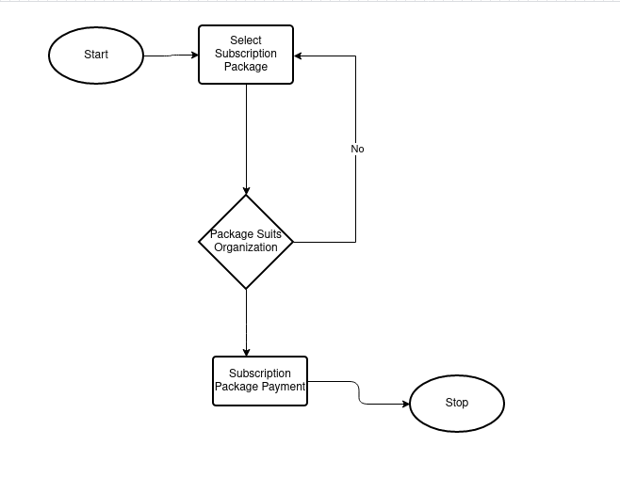

##### Figure 1. Subscription Package flowchart

#### **3.3.1.1 A Sign up Flowchart**

For any user to sign up with the SaaS Subscription management ecosystem, they will give their personal information that is names, email, phone numbers and payment details. The system will cross-reference the given details with the ones residing on the database, if any of them matches, like email, phone numbers it will notify the user that there is an existing user with those details. This prevents double entry and also a way of error handling too. When the user data does not match any existing records, it will capture that information and store it in the database and then notify user that they can proceed to sign up. The below diagram shows sign up flowchart.

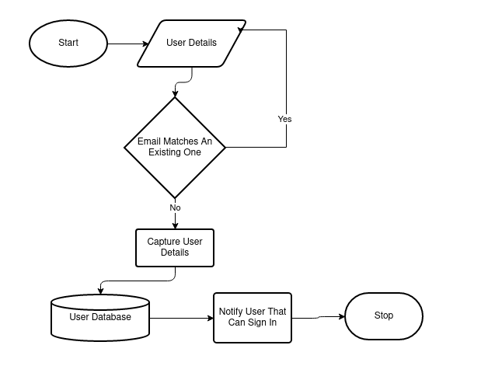

##### Figure 2. Sign up flowchart

#### **3.3.1.2 A Sign in Flowchart**

For any user to access the proposed system, they will have to sign in provided that they have already created an account with the Subscription Management Ecosystem. On sign in panel, the system will prompt the user to enter authentication details that is, Username, email or staff number (this will vary from organization to organization) and password.

The system will cross-reference the authentication credentials that the user has entered with the existing ones on the database. If the match, the user is granted access.

If the user performs more than five wrong attempts, the system will automatically lock the account and notify the administrator. The figure below is a flowchart that diagrammatically explains the user sign in process.

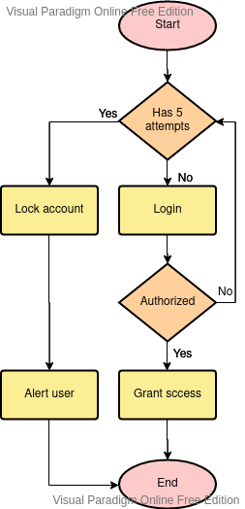

##### Figure 3. Sign in flowchart

#### **3.3.1.3 A Subscription Package Payment and Renewal Flowchart Using Credit Cards**

Client subscriptions payments and renewals will be one core function of the subscription management ecosystem of SaaS ERP, because it will be the one responsible for managing clients (Subscribed organizations) continuous usage of the ERP. In order to keep their subscription running, they will have to renew it on monthly or yearly basis based on the subscription package they chose, and this process will be managed by a Credit Card Processing Application Programming Interface (API), which will be a third-party module integrated in the Subscription Management Ecosystem, which will be responsible for credit card payments.

The below figure, which is a flowchart indicates how subscription payment and renewal process will take place.

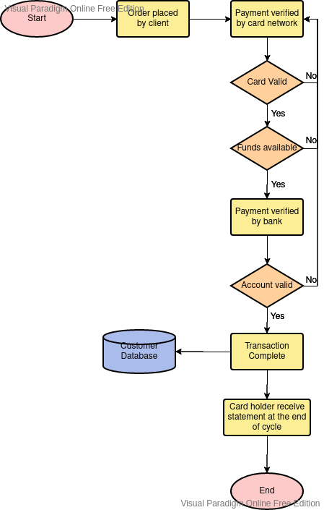

##### Figure 4. Subscription Package Payment and Renewal Flowchart Using Credit Cards flowchart

#### **3.3.1.4 Sales Management Flowchart**

One core function of the proposed system is sales management. Sales management varies from one organization to the other but they all share some similarities under the hood. From the diagram below – which is an over view diagrammatical representation of sales management flowchart, the customer submits an order, sales department will receive the order and forward it to the contracts department, if it meets organization standards it will be approved else it will fall back and customer will be notified that the organization cannot process their order else the order will be fulfilled and shipped.

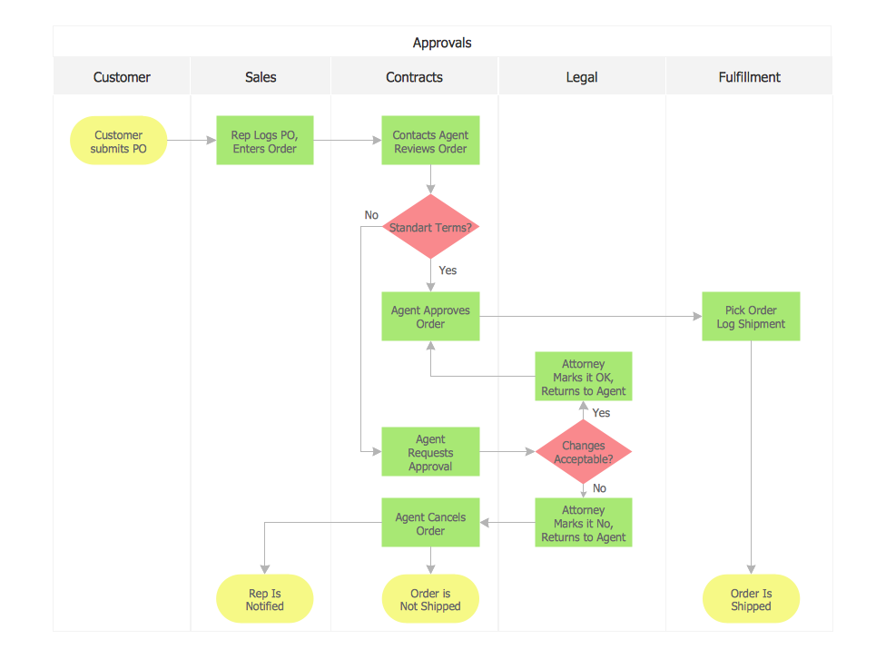

##### Figure 5. Sales Management Flowchart

#### **3.3.1.5 Jobs and Projects Management Flowchart**

Jobs and projects management is a core functionality of the proposed system although this feature may not be consumed by many organizations. The below flowchart, diagrammatically breaks down this feature. Many organizations have project managers which are responsible for each and every set of tasks which the organization has to undertake in order to achieve given goals. Project managers comes up with new sets of tasks, they add backlogs and sorts them with a scheduling system which groups the tasks from the ones with the highest priority.

These tasks are forwarded to developers, or any other employees in the organizations where they work on them accordingly, then they are forwarded to quality assurance personnel’s who test and mark that the tasks are complete. This process is diagrammatically represented on the flowchart below.

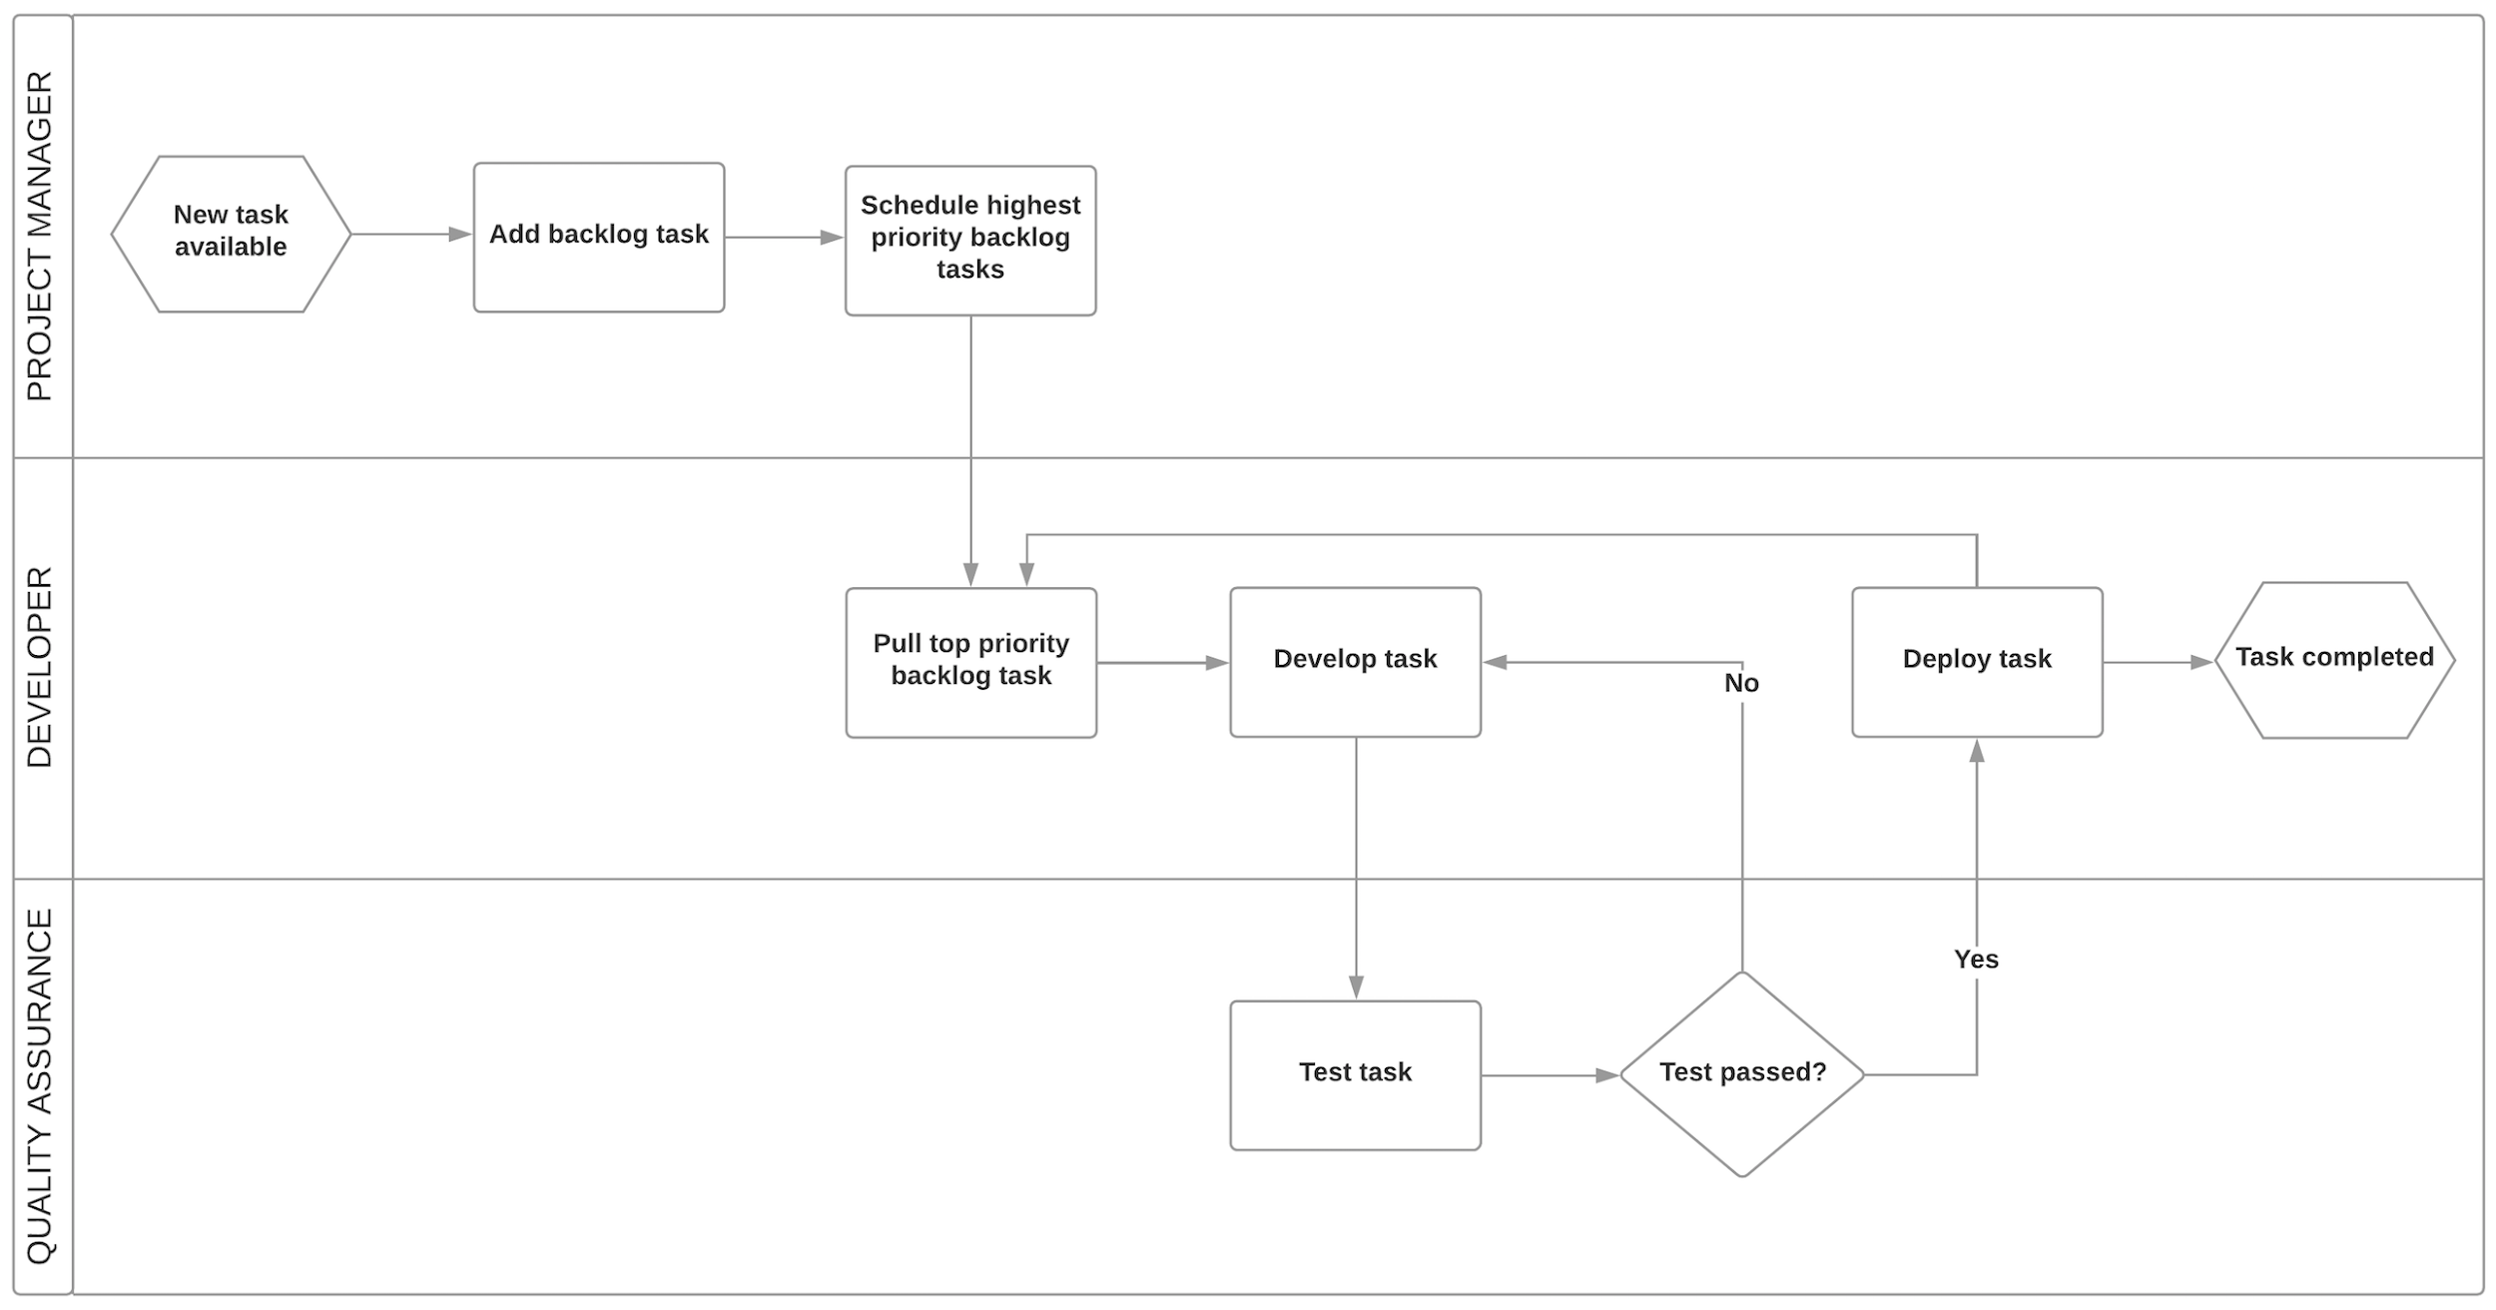

##### Figure 6. Jobs and Projects Management Flowchart

#### **3.3.1.6 Inventory Management Flowchart**

Inventory and corporation assets management is another core feature of the proposed system. Below flowchart breaks down this feature.

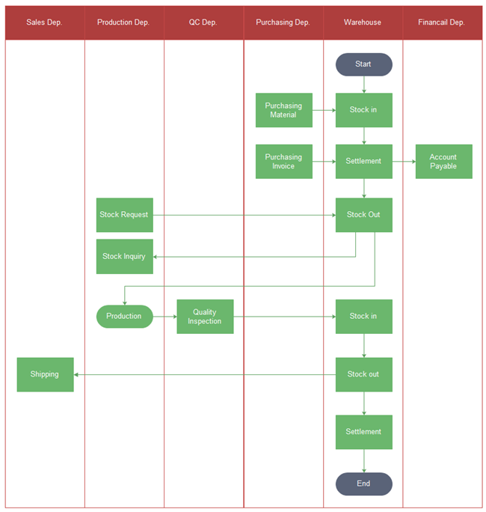Figure 7. Inventory Management Flowchart

#### **3.3.1.7 Third Party Payments Integrations Feature Flowchart**

The proposed system will utilize third party payment integrations will ease the payments and transactions process. The diagram below is a flowchart which de-mystifies the payments integrations process. With this integratedpayment systems, transactions will be automatically entered into ERP and applied to ledger. This payment integration will speed up cash flow and put more money in the target client account. Payments will be automatically posted with integrated credit card processing.

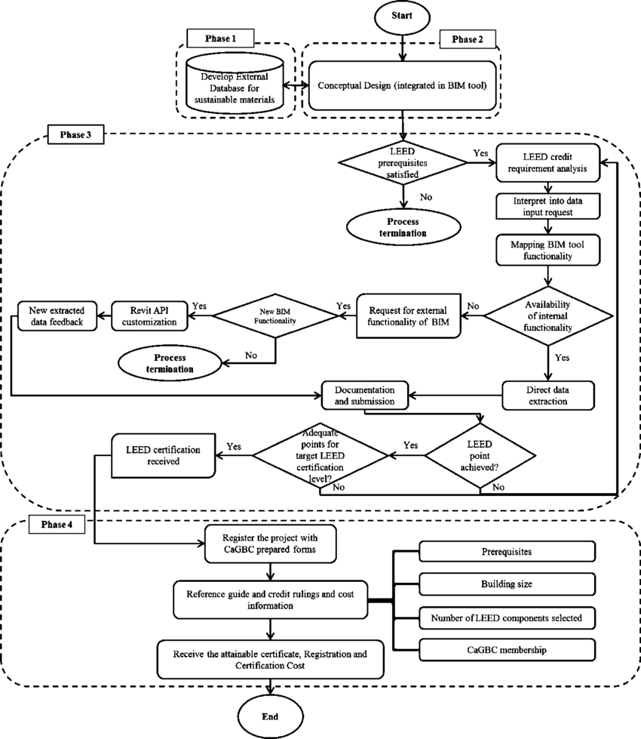

##### Figure 8. Third Party Payments Integrations Feature Flowchart

### **3.3.2 Data Flow Diagram**

#### **3.3.2.0 Subscription Management Eco System Data Flow Diagram**

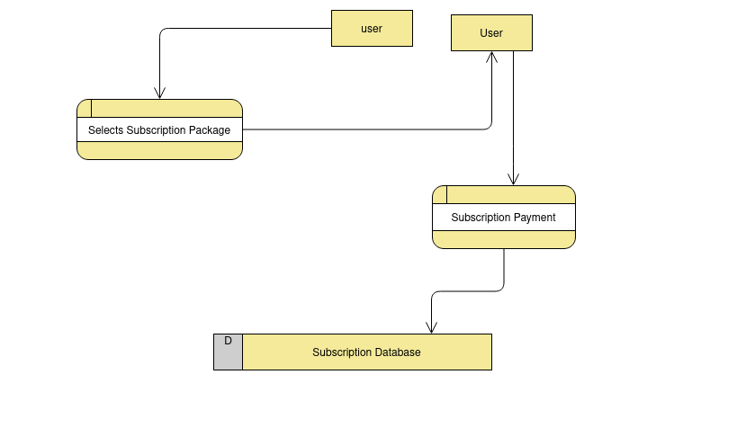

##### Figure 9. Subscription Management Eco System Data Flow Diagram

#### **3.3.2.1 ERP System Data Flow Diagram**

The below diagram, represents diagrammatically data flow between of the entire ERP modules.

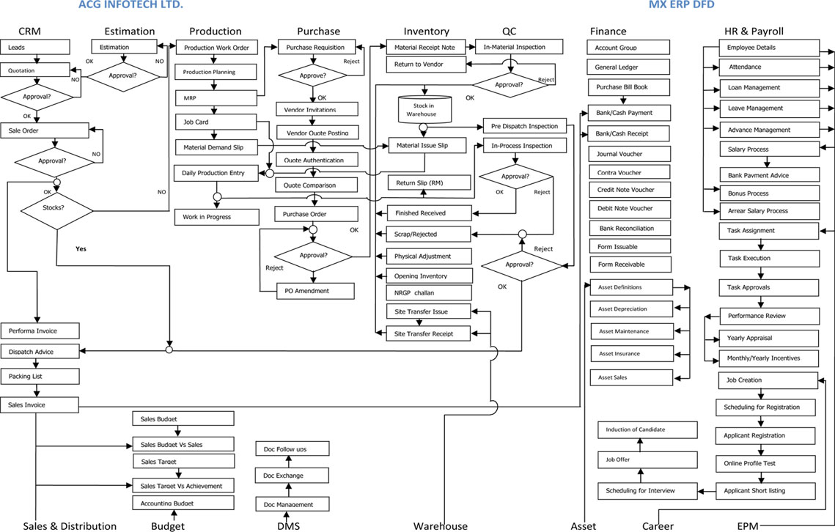

##### Figure 10. ERP System Data Flow Diagram

## **3.4 Method for Developing**

The methodology which will be used to develop the proposed system is waterfall. It has a sequence of steps which include: requirements gathering and analysis, system design, implementation, integration and testing, deployment and maintenance.

### **3.4.1 Gathering the requirements**

Based on inflectra (2018) understanding, this is done by systematically identifying what a system or a software requires in order to run or function. This includes users who will use the system, system support which includes its capability towards targeted function, technical, quality, assumptions and acceptance. (infractra, 2018)

### **3.4.2 Design**

According to Joshua Feldman (2016) design process deals with developing codes and creating secured website in order to come up with the desired functionality of the system and goals.(Feldman, 2016)

### **3.4.4 Implementation**

This is the third phase in the project management life cycle and it involves putting project plans into action. The developer will coordinate and direct project resources to meet the objectives of the plan. This phase actually contains what the project does to produce deliverables or what it delivers in terms and services or products. The proposed system will be implemented using JavaScript, CSS3 and HTML5 for front end, it will use AJAX and PHP for Server Side scripting and SQL for backend and as database manipulation language.

### **3.4.5 Verifying and Testing**

Under this phase, the developer checks and demonstrates whether the predefined inputs met the expected results or outputs. Developers will code, debug and run the system before its release to the organizations or used by any other person. Testing is also carried on to enable user’s satisfaction depending on the service offered by the system.

### **3.4.6 Maintenance**

This is the last phase in the project life cycle on the waterfall model. Maintenance means that after the system has been tested and verified, the changes need to be corrected to improve system performance, enhance security and address user requirements.

## **3.5 Method of Transition**

This study proposed to use the pilot change over as a method of transition where the new system is first introduced and run in the low level departments of the target organizations before it spread out to the top managerial other departments. This is because these departments seem to have more knowledge and experience on how the organization works and it will be easier for them to adapt the new system. The new system will later penetrate or spread to the other top managerial departments.

## **3.6 Screenshots of the Proposed System**

The proposed system screenshots consists of the following Subscription management ecosystem and various ERP Modules.

### **3.6.1 Subscription Management Ecosystem Screenshots**

Subscription management ecosystem will hold all the subscription payments and billings. The panel shown in the screenshot below will allow user to select any subscription package that suits their organization needs.

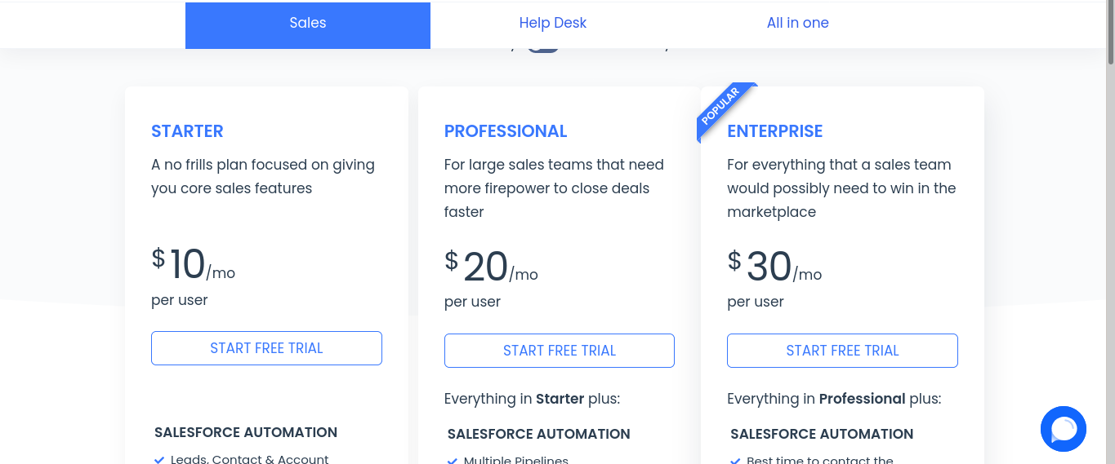

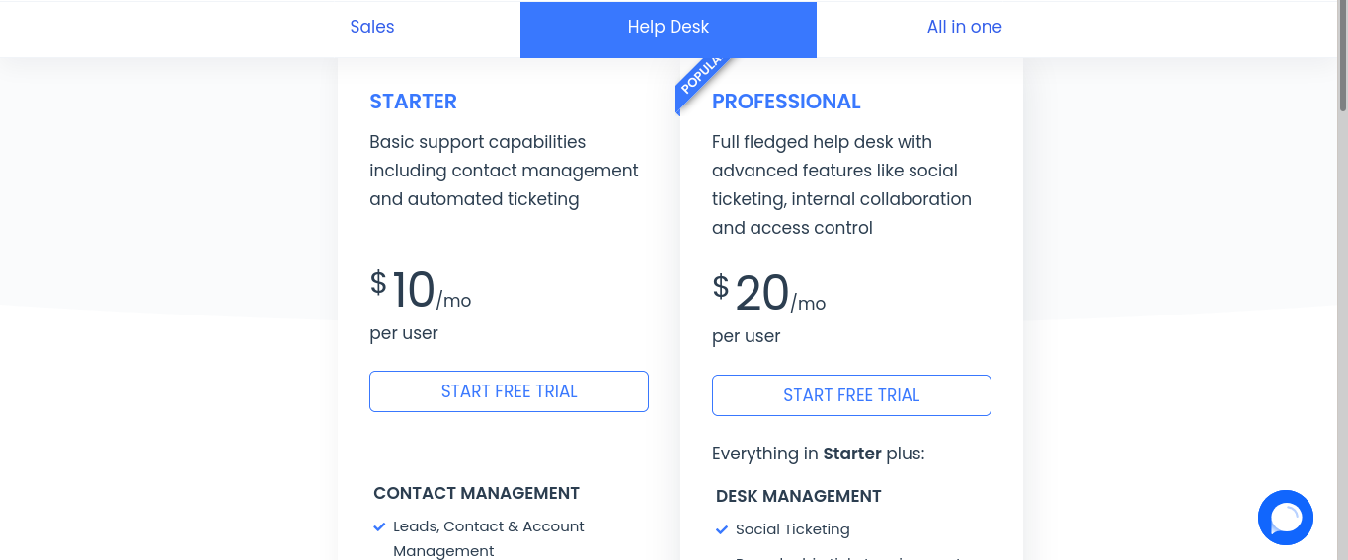

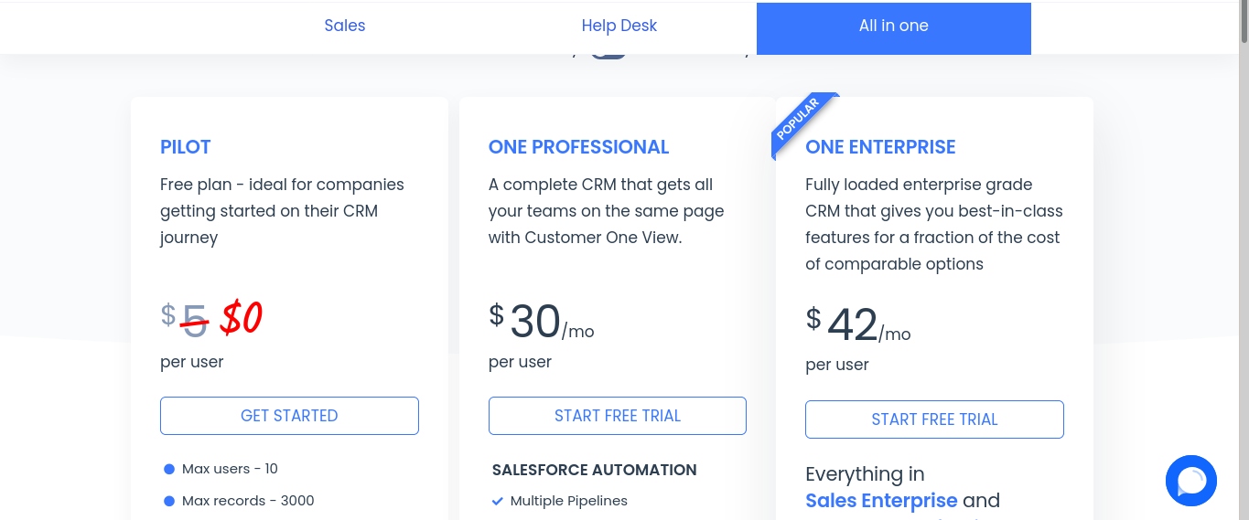

### **3.6.2 ERP Modules Screenshots**

The image below is a login page will authenticate any user to access the underlying modules of the ERP.

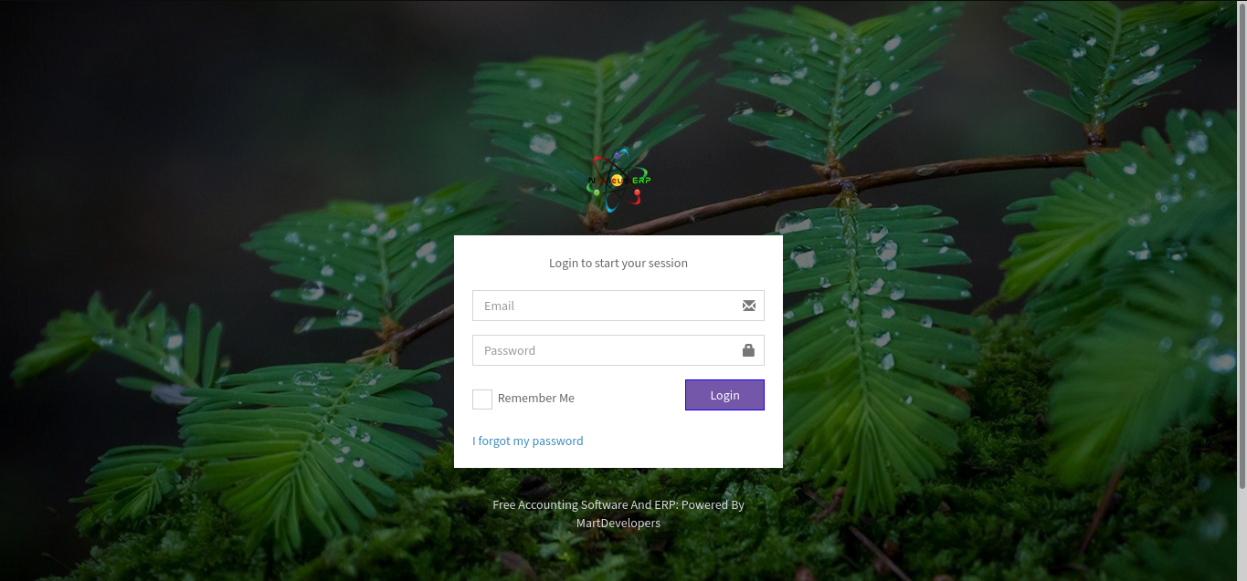

After a successful authentication, logged in user will be re directed to this page which is the dashboard. It gives information at a glance that is Total incomes, total expenses, total profit, a graph indicating a cash flow, pie charts indicating organizational incomes per categories, organizational expenses by categories, account balances and many more. From this panel, user will be able to proceed further to the system modules.

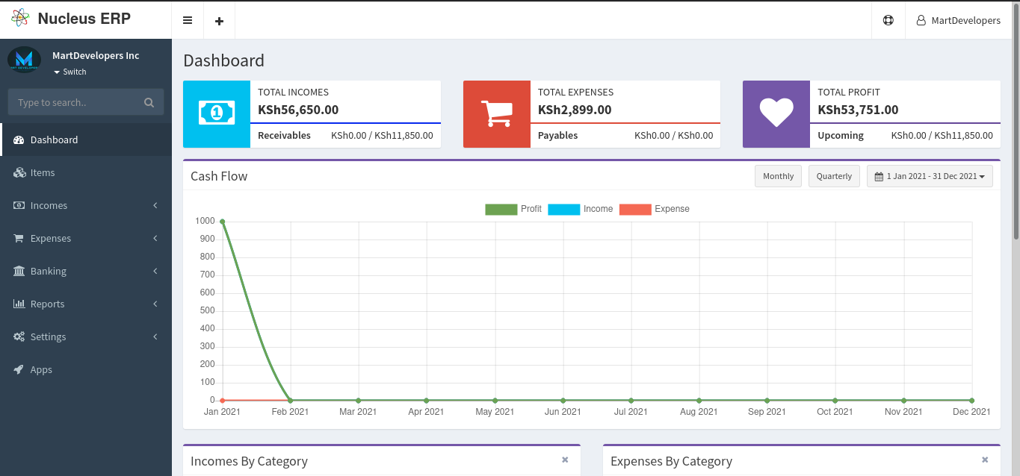

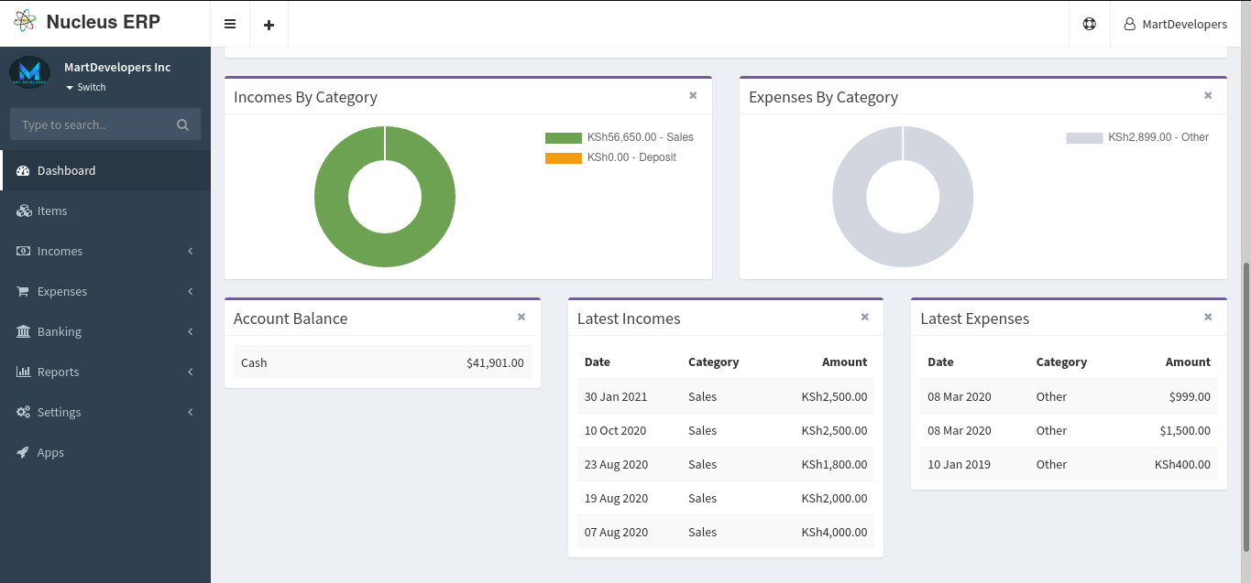

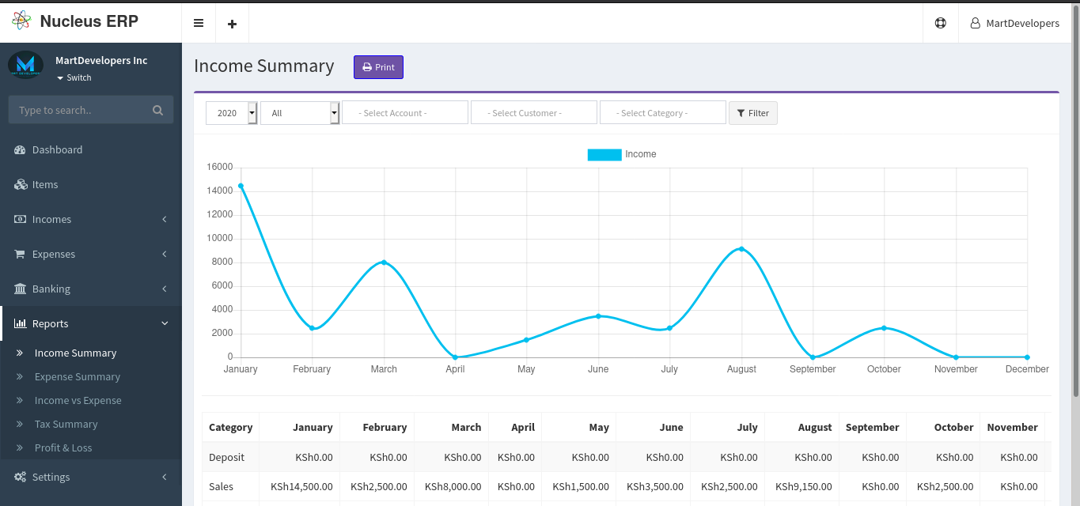

## **3.7 Conclusion**

The study concludes that adoption of Software as a Service ERPs contributes to improved organizational performance of target organizations and companies. Organizations wishing to adopt these SaaS ERPs are able to better serve their customers and have reduced operating costs and increased margins.

Organizations are able to focus on their core business without having to worry about the system

Taking over their time and resources. The study also concluded that SaaS ERP allows different departments with diverse needs to communicate with each other by sharing the same information in a single system. SaaS ERP thus increases cooperation and interaction between all business units in an organization on this basis. Also, SaaS ERP standardizes processes and data within an organization with best practices. The company also streamlines data flow between different parts of a business by creating a one-transaction system.

# **References**

Alhaisoni, M. (2008). On the Advancements in Cloud Computing Technology: An Overview. *IJCSIT) International Journal of Computer Science and Information Technologies*, *6*(3), 2772–2778.

Arik Ragowsky, T. M. S. (2002). Enterprise resource planning. *Journal of Management Information Systems*, *19*(1), 11–15.

ERPNext. (2021). In *Wikipedia*. https://en.wikipedia.org/w/index.php?title=ERPNext&oldid=1002387462

GAAP, U. (2012). *SAP Business ByDesign*.

Ganesh, A., Shanil, K. N., Sunitha, C., & Midhundas, A. M. (2016). OpenERP/Odoo-an open source concept to ERP Solution. *2016 IEEE 6th International Conference on Advanced Computing (IACC)*, 112–116.

Jamsa, K. (2012). *Cloud computing: SaaS, PaaS, IaaS, virtualization, business models, mobile, security and more*. Jones & Bartlett Publishers.

Johansson, B., & Ruivo, P. (2013). Exploring factors for adopting ERP as SaaS. *Procedia Technology*, *9*, 94–99.

Lenart, A. (2011). ERP in the Cloud–Benefits and Challenges. *EuroSymposium on Systems Analysis and Design*, 39–50.

Rashid, M. A., Hossain, L., & Patrick, J. D. (2002). The evolution of ERP systems: A historical perspective. In *Enterprise resource planning: Solutions and management* (pp. 35–50). IGI global.

Shankar, C., & Bellefroid, V. (2011). *Microsoft Dynamics Sure Step 2010*. Packt Publishing Ltd.